**Question for Assignment 2b**

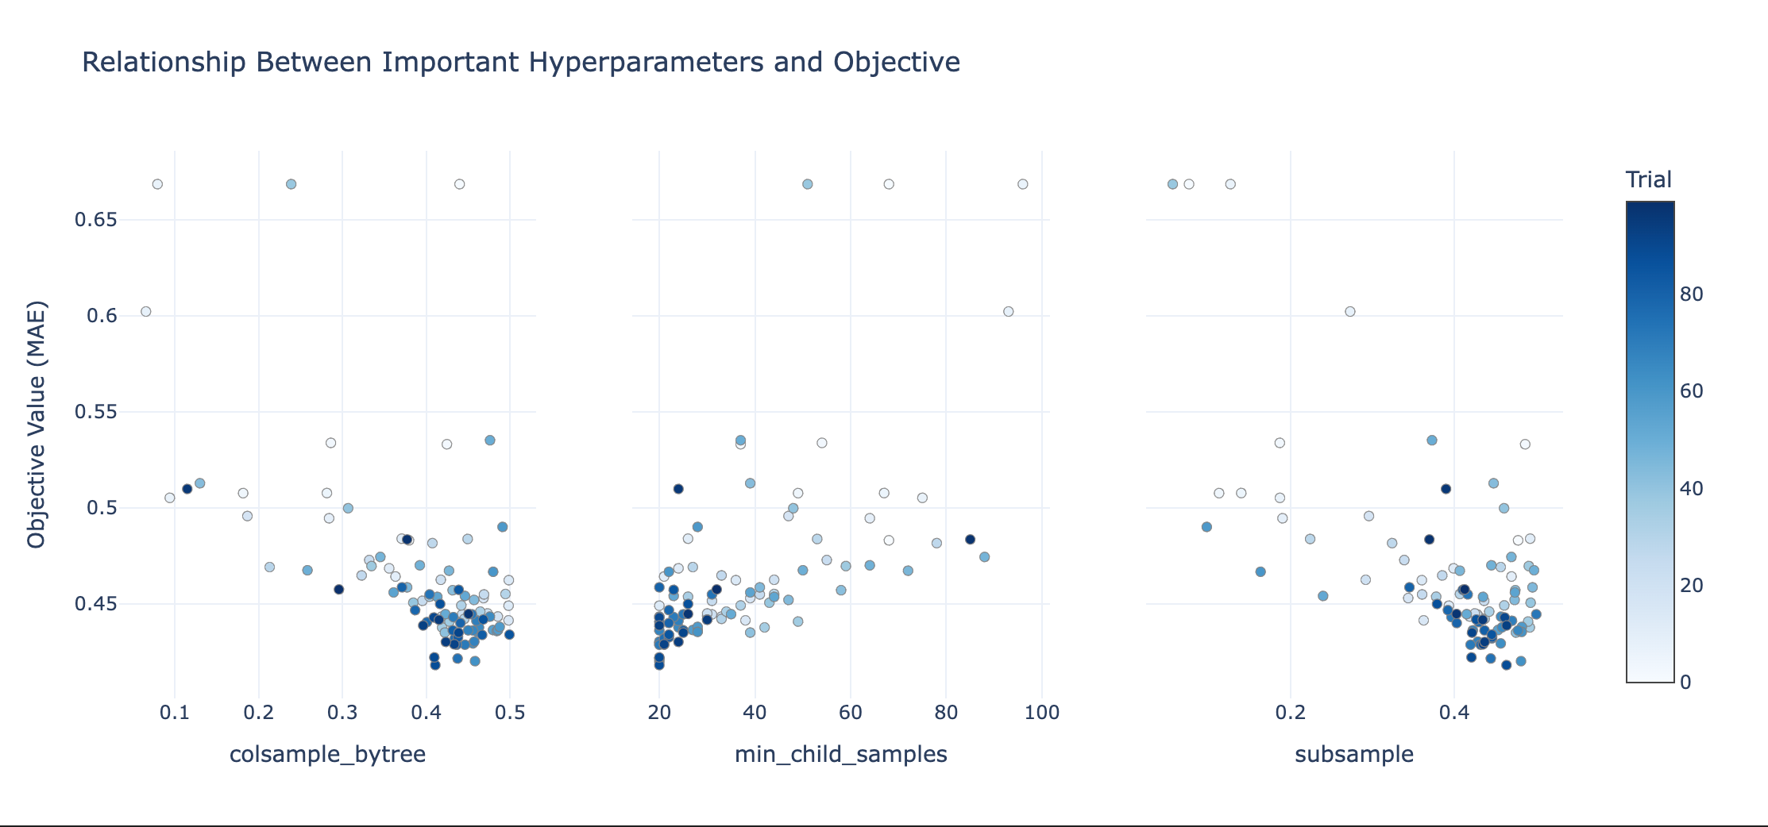

As we can see from the picture,

colsample_bytree: points that can have lower MAE value are around 0.4

min_child_samples: points that can have lower MAE value are around 20

subsample: points that can have lower MAE value are around 0.4

further adjustment for next study:

colsample_bytree: [0.4, 0.5]

min_child_samples: [15, 30]

subsample: [0.4, 0.5]

By narrowing the search ranges, the optimizer will focus on areas that are more likely to yield better MAE values.

**Screenshot for Assignment 2c**

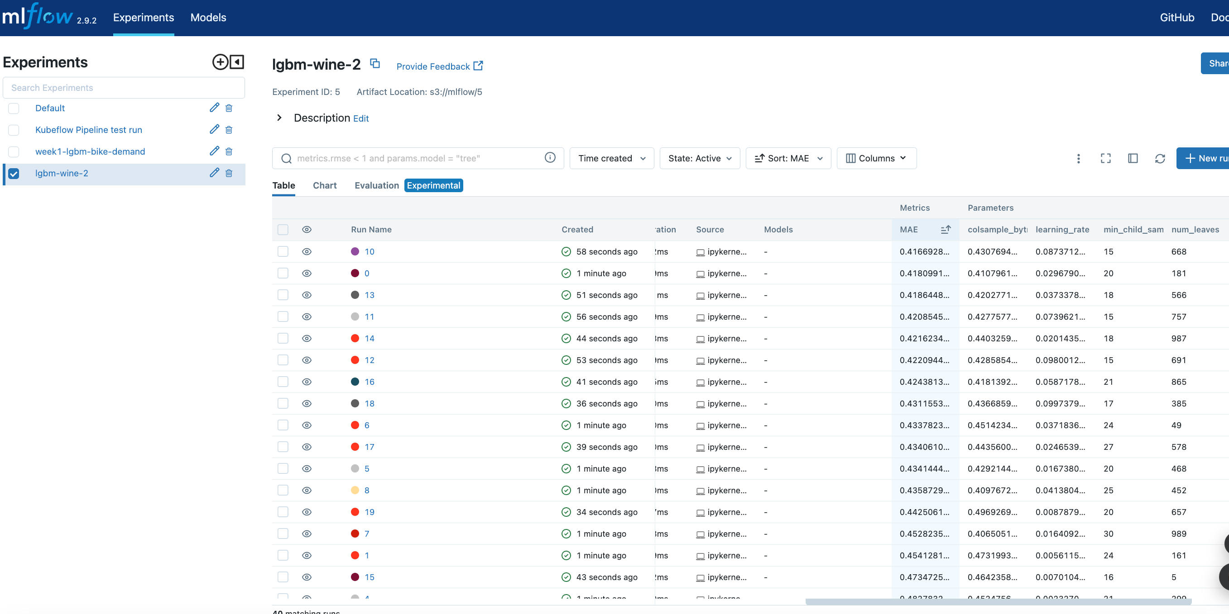

**Screenshots for Assignment 3b**

